# How to Access the Supervision Page

1. From your online portal click "My Information"

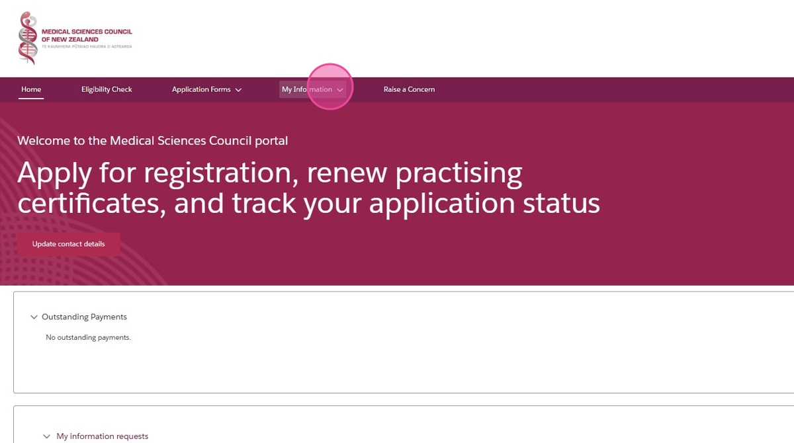

1. Click "Supervision"

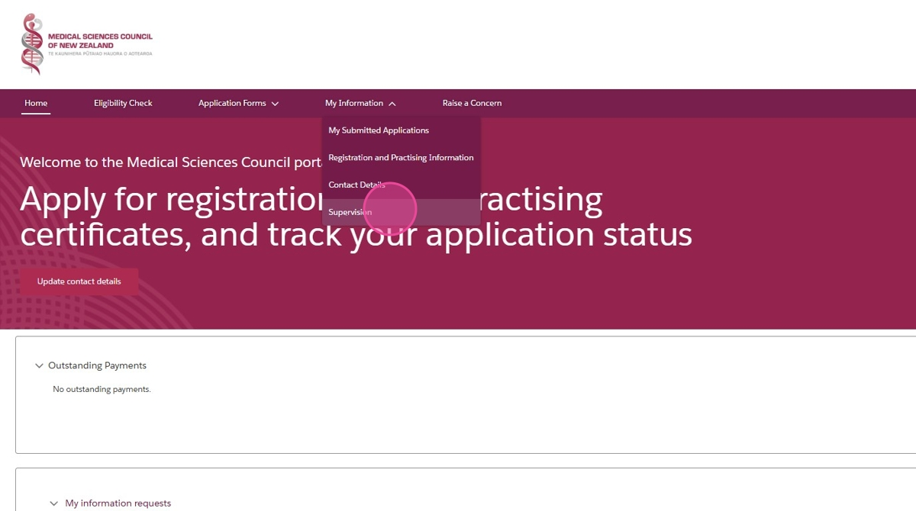

# For Supervisees: How to Add or Change your Supervisor

1. From you supervision page, click "Change Supervisor"

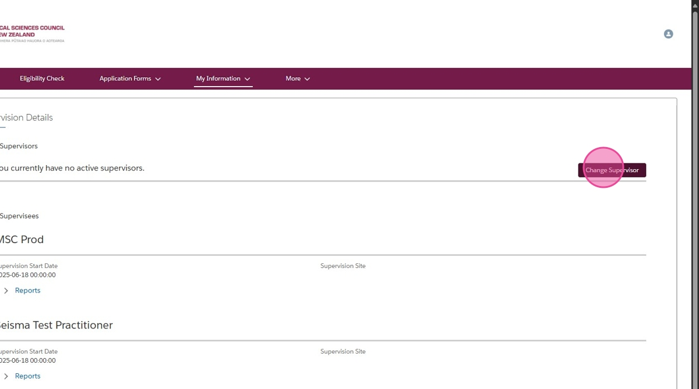

1. Provide a reason why you are changing your supervisor and click "Next"

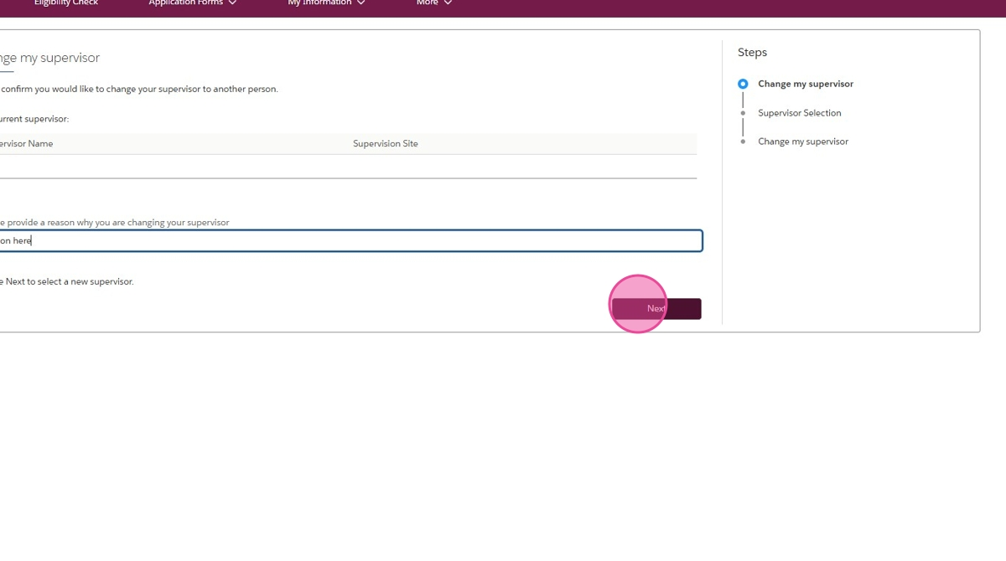

1. Provide your supervisors name, your supervision site, and your start date. Click "Next"

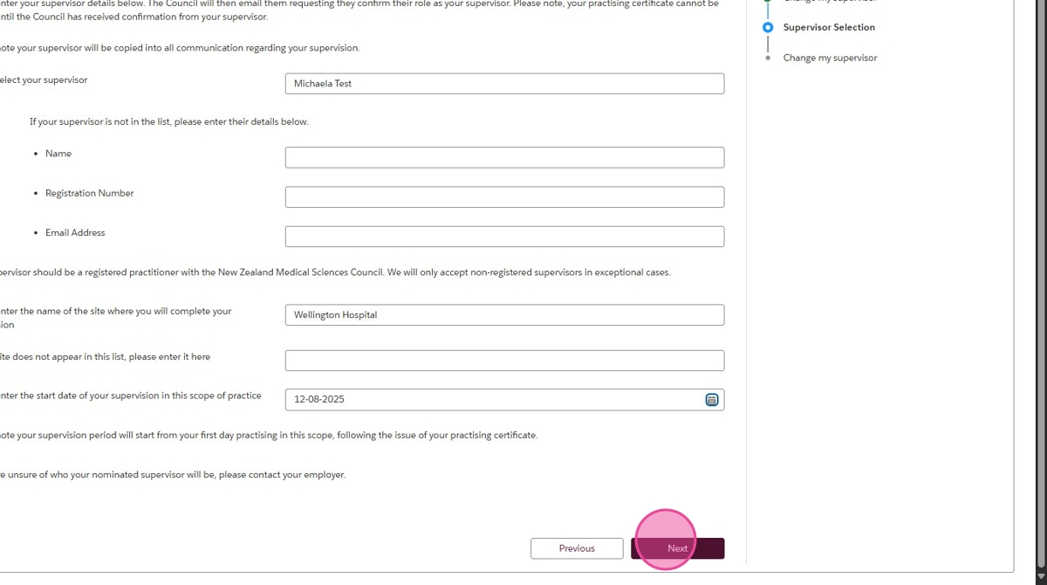

# How to Become a Supervisor and Complete the Quiz

1. From your supervision page, click "Become a supervisor"

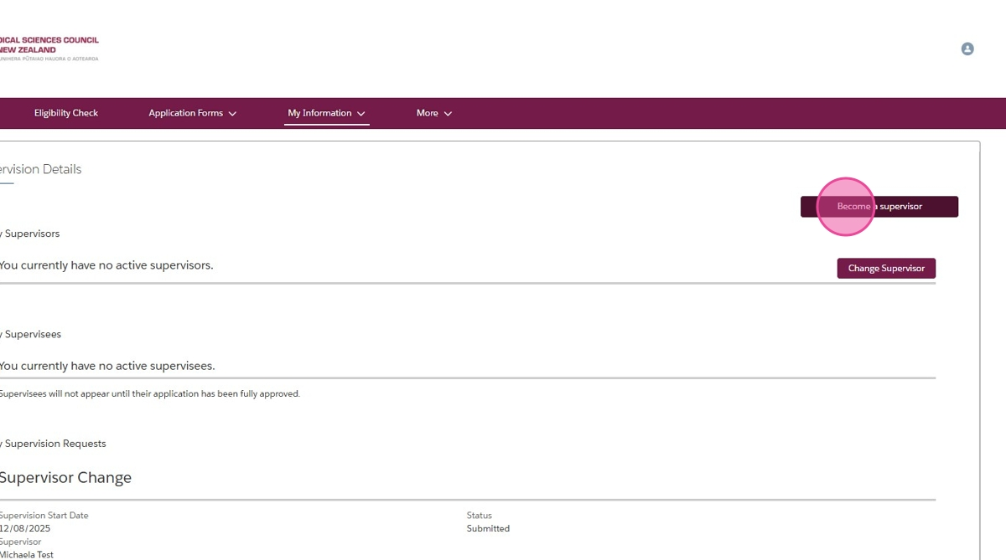

1. Check the boxes that apply to you, and click "Submit"

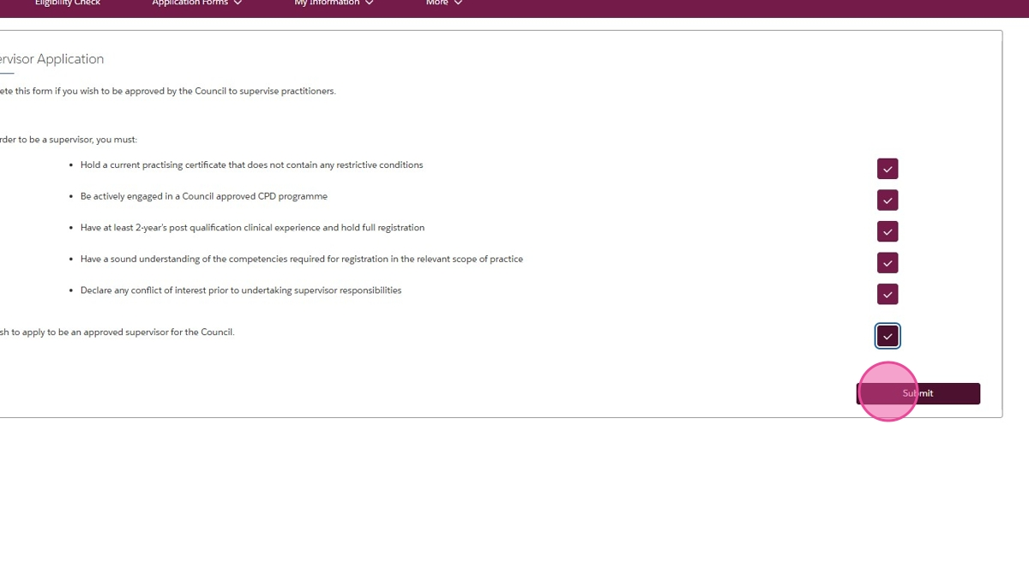

1. If you are an Anaesthetic Technician, once we have done an initial check of your application, you will receive an email from us letting you know you may now complete the supervisor quiz. From the "Supervision" page of your portal, click "Complete Quiz"

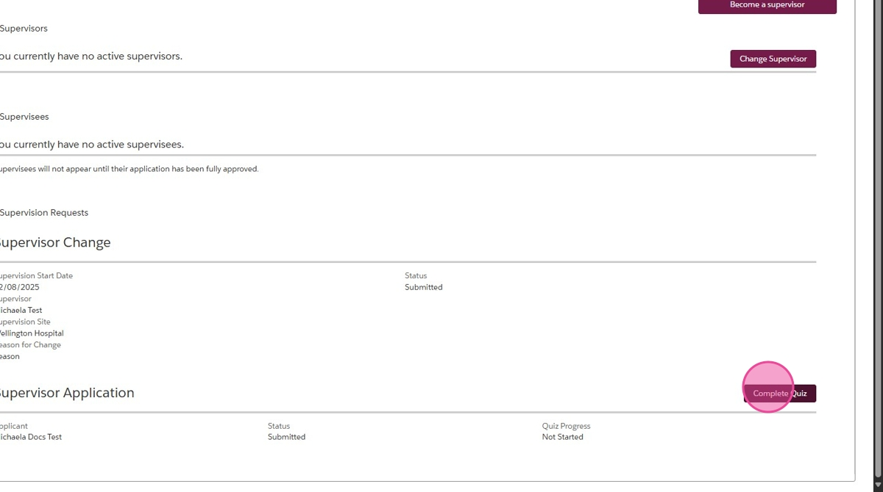

1. Once you have completed the quiz and your application to become a supervisor has been approved, we will email you to let you know. Supervisees will then be able to select you when applying for their APC or completing a change supervisor application.

# For supervisors: how to accept or decline a supervision request

1. You will have received an email letting you know you have been nominated as a supervisor for someone. From your supervision page, find the supervisee and click "Accept"

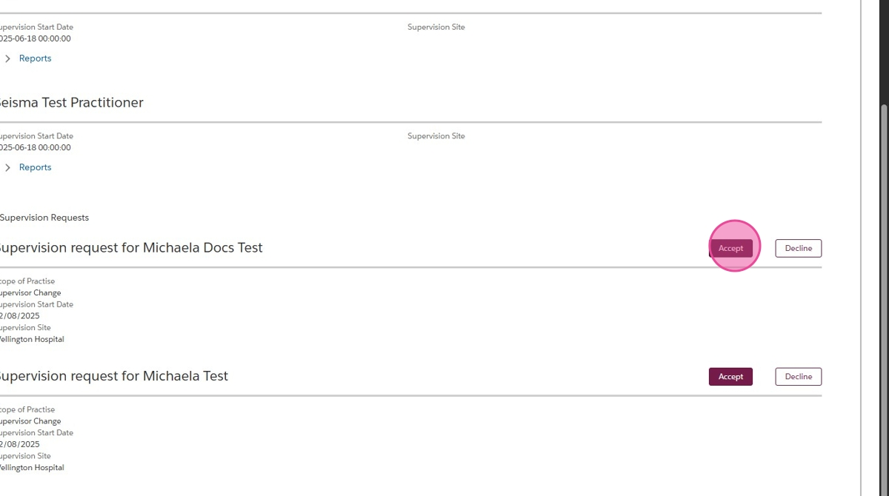

1. Or you can click "Decline"

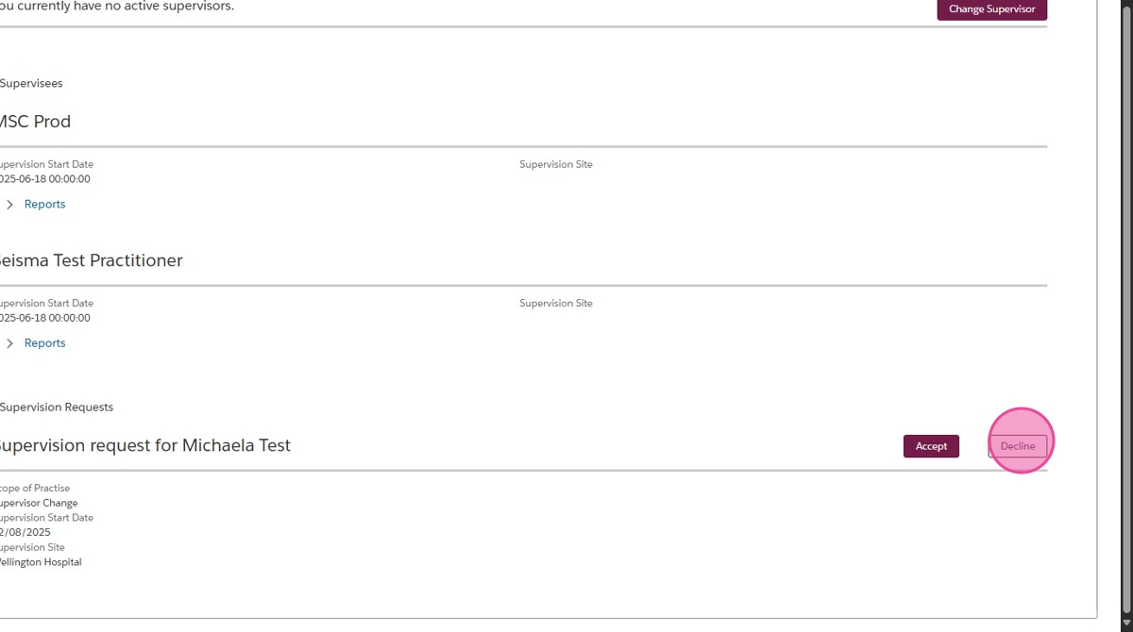

1. Type a reason for declining and click "Decline"

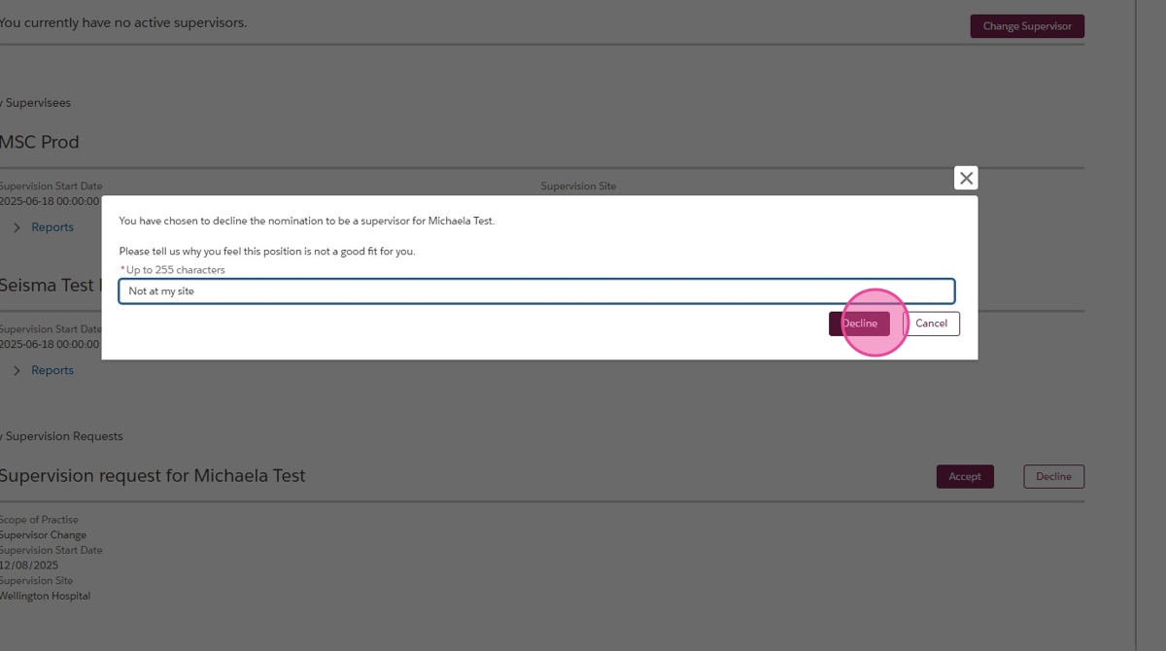

# For Supervisors: How to Submit a Supervision Report

1. If you need to find the report templates, they are on our website under "Resources"

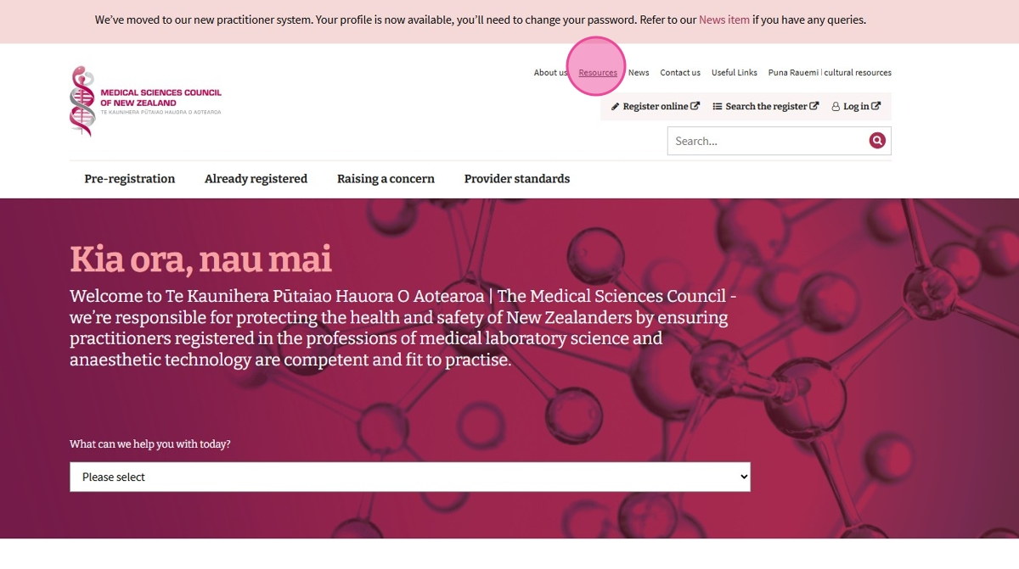

1. From the supervision page of your online portal, click "Reports" under the supervisee you would like to submit for.

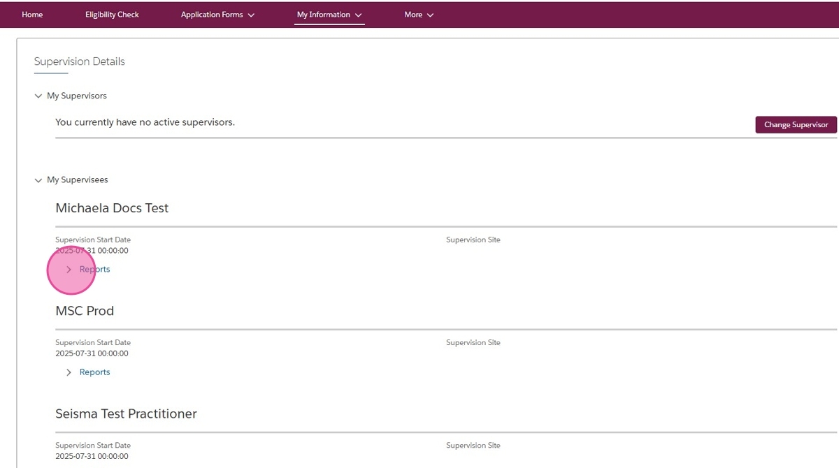

1. Click "New"

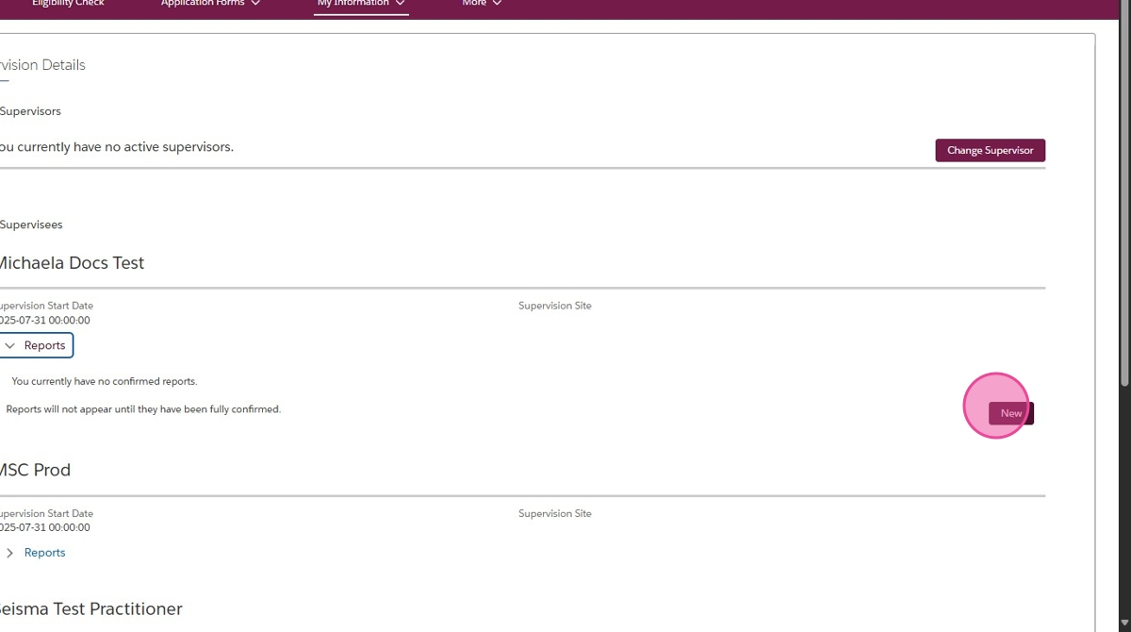

1. Provide any comments in the comment box. Select whether the applicant is ready for sign off. Please select option B for final sign off, even if it is not an early sign off request. Upload your final report and any applicable supporting documents such as early sign off support. Once you have uploaded the documents, you won’t be able to see them anymore, so please make sure you have named them in a way that lets you know you have uploaded the right document. Then click "Submit"

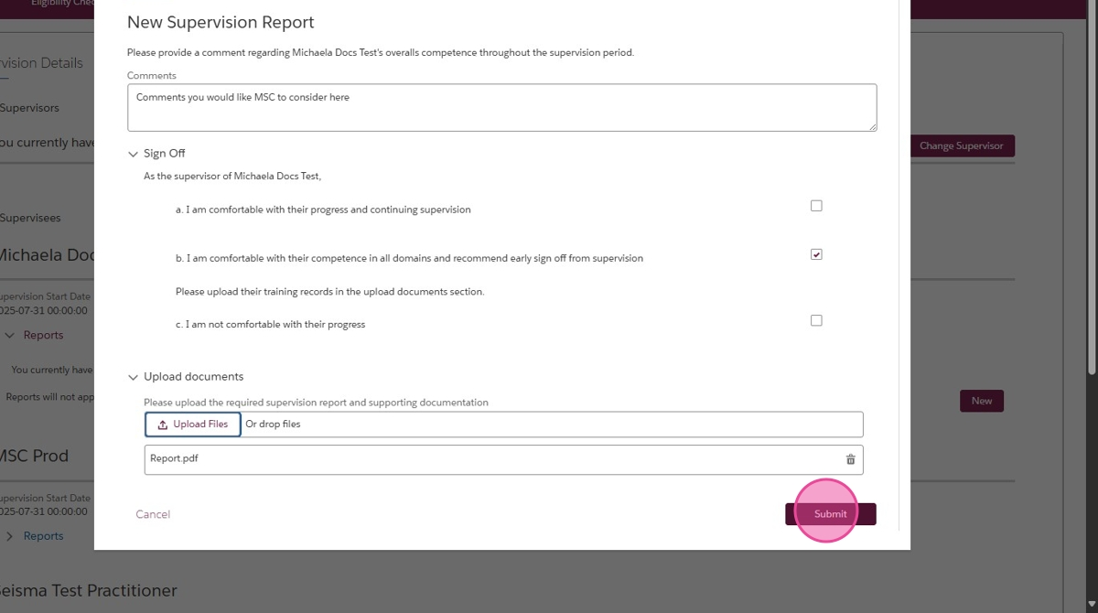

1. Once we have reviewed the report, we will email the supervisee to let them know the outcome.